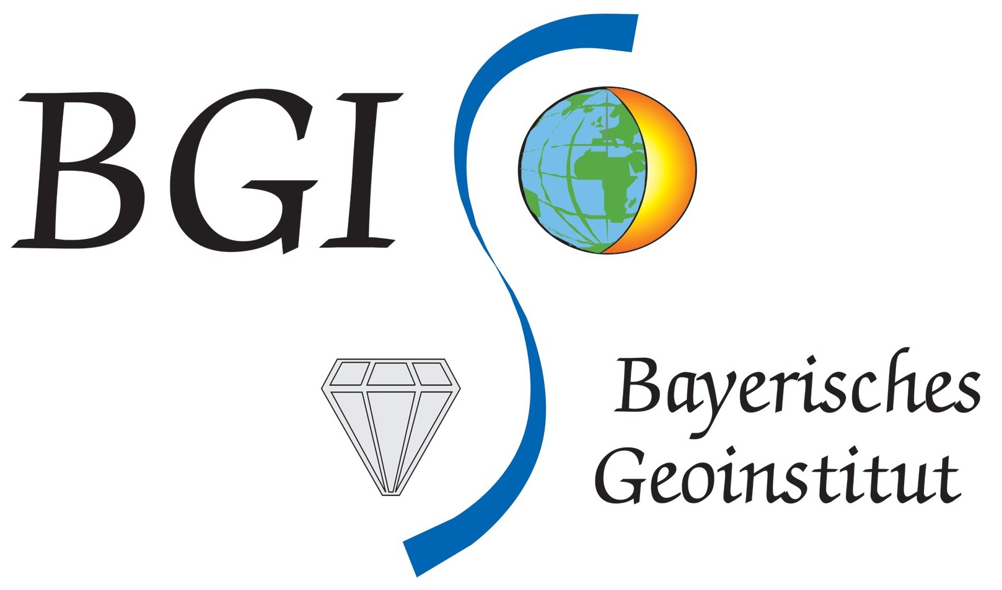 | Short Course: February 19-23, 2024  (Bayerisches Geoinstitut, Universität Bayreuth, Bayreuth, Germany)

“High-Pressure Experimental Techniques and
Applications to the Earth’s Interior”

Application Form

Please return to:  Deadline:  January 7, 2024 | 2024 High-Pressure Short Course  Bayerisches Geoinstitut  Universität Bayreuth  D-95440 Bayreuth/Germany | Fax: +49 (0)921 55 3769 or:  email: florian.heidelbach@uni-bayreuth.de

Last name, First name:
Postal Address:

Tel. Number: e-mail address:
Current position:
Academic background/
degrees earned:

Major field of study / Number of semesters:

Student member of Deutsche Mineralogische Gesellschaft (DMG)

If you are engaged in a Diploma (M.Sc.), a Ph.D. Dissertation, or in post-doctoral research, please provide
a short description of your research topic:

Name and address of a referee (e.g. M.Sc. or Ph.D. supervisor):

List experimental and analytical techniques which you are already familiar with:

List any techniques that you are particularly interested in learning about during the Short Course (see also under “facilities” on our homepage https://www.bgi.uni-bayreuth.de/):

I want to obtain ECTS credit points and will pass a written examination after completion
of the course

Additional remarks:

Signature: Date:

Details under: https://www.bgi.uni-bayreuth.de/ShortCourse2024

